**CSC 1101 – Problem Solving and Programming Laboratory**

**Lab 11 – Omar Faruk**

**25 points – Due October 13, end of lab**

**a)** Save this document with your name and the lab assignment number somewhere in the file name.

**b)** Type/paste your answers into the document.

**c)** Submit this document to the Canvas item where you downloaded this document.

As a computer programmer, you are hired by facebook.com to write a program which can manipulate the status (which is written in text). You need to do the following:

1. Prompt for and get from the user a status in the form of a string.
2. Find the length of the string. If the length is <10 characters or greater than 50 characters, print an error message.
3. If the length of the string is valid, print the string and its length. Then loop through the string and print the reverse of it. Use a while loop that starts at the end of the string.

Sample Input/Output will be helpful to write your code. Attach a different input/output for your submission.

**Sample Input/Output:**

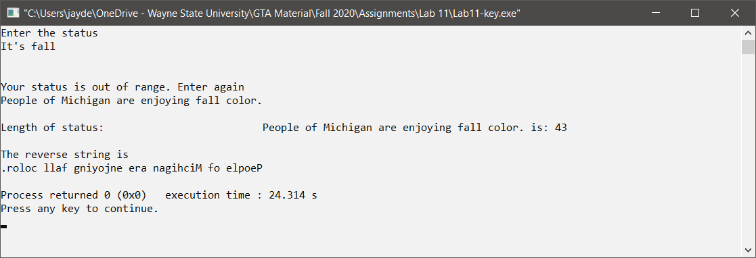

*[your program code here]\**

//==========================================================

//

// Title: Reverse Text Generator

// Course: CSC 1101

// Lab Number: Lab 11

// Author: Omar Faruk

// Date: 10/13/2020

// Description:

// Taking an user input to print it in reverse

// using while loop for validation and for loop for string reverse

//

//==========================================================

#include <cstdlib> // For several general-purpose functions

#include <fstream> // For file handling

#include <iomanip> // For formatted output

#include <iostream> // For cin, cout, and system

#include <string> // For string data type

using namespace std; // So "std::cout" may be abbreviated to "cout"

int main()

{

// Declare Constants

const int COLMFT1 = 50;

const int COLMFT2 = 50;

// Declare variables

string status1;

int length1;

//User input

cout << "Enter the status: " << endl;

getline(cin, status1);

cout << endl;

// While Loop for Validation

length1 = status1.length();

while (length1 < 10 || length1 > 50)

{

cout << "\nYour status is out of the range. Enter again" << endl;

getline(cin, status1);

length1 = status1.length();

cout << endl;

}

cout << setw(COLMFT1) << left << "Length of status: "

<< setw(COLMFT2) << right << status1 << " is: " << length1 << endl;

cout << setw(COLMFT1) << left << "The reverse string is " << endl;

//For Loop to print in reverse

for (int i = (length1 - 1); i >= 0; i--)

cout << status1[i];

}

*[your program output here]\*\**

